CS 255 System Design Document Template

Binathi Podalakuru

UML Diagrams

UML Use Case Diagram

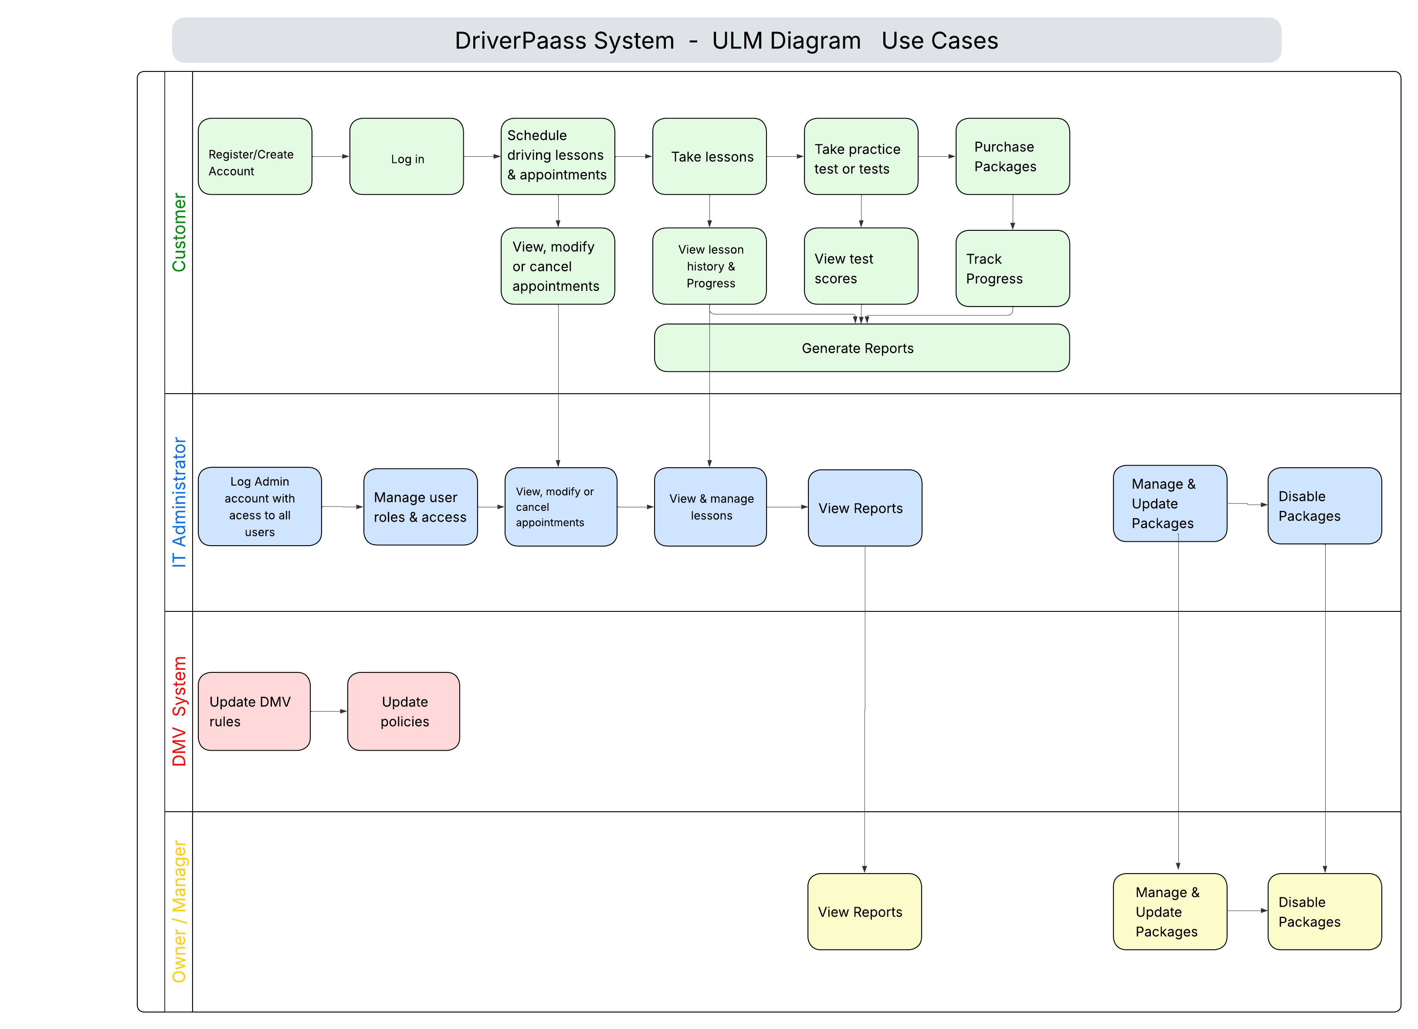

UML Activity Diagrams
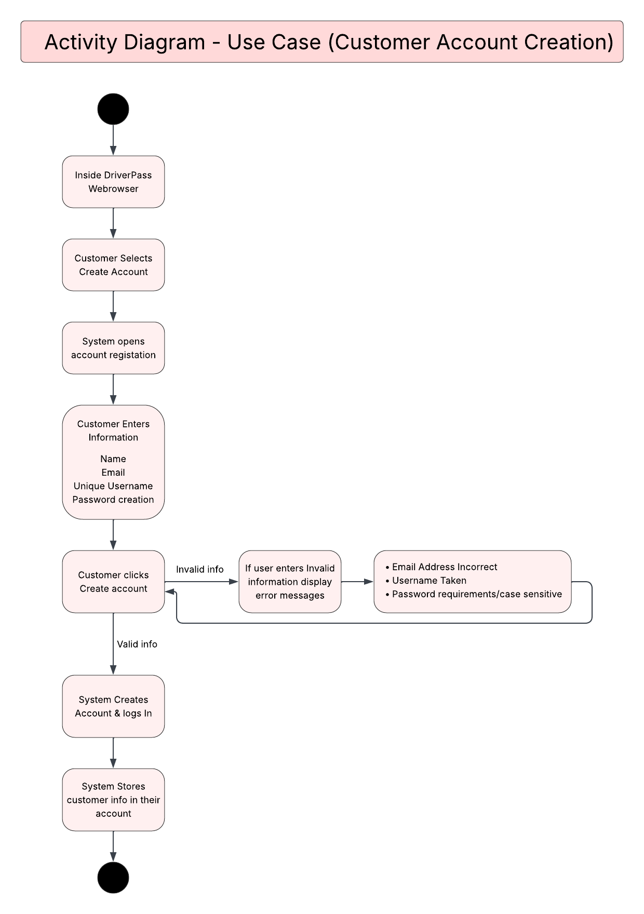

UML Sequence Diagram

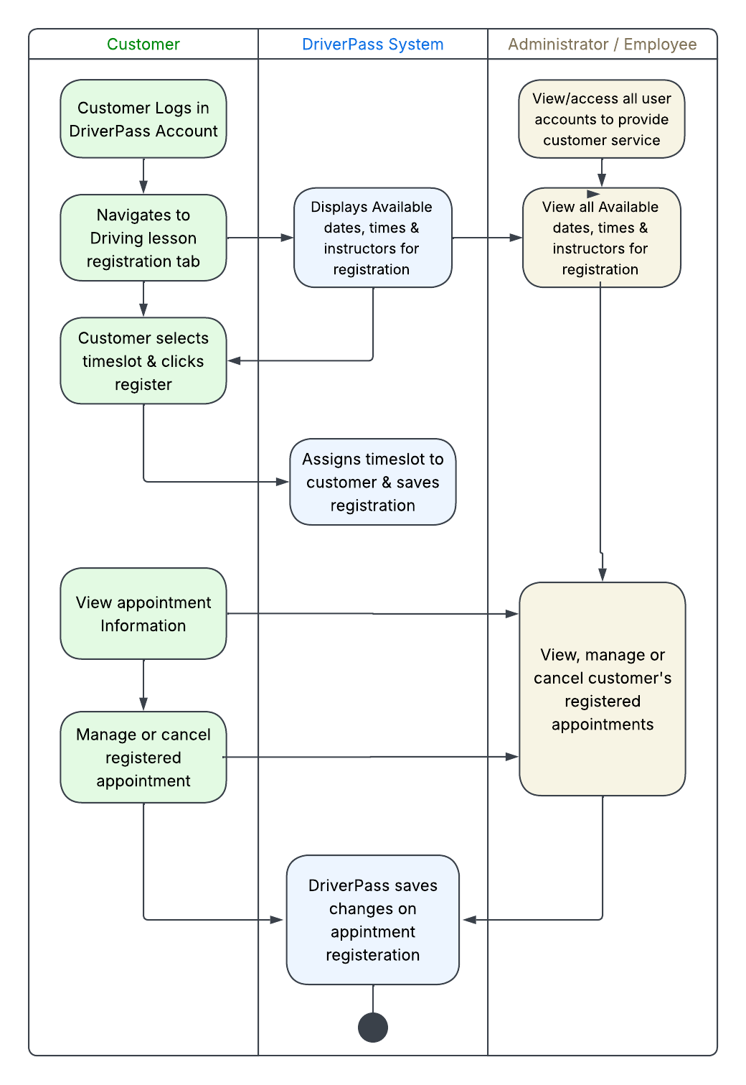

UML Class Diagram

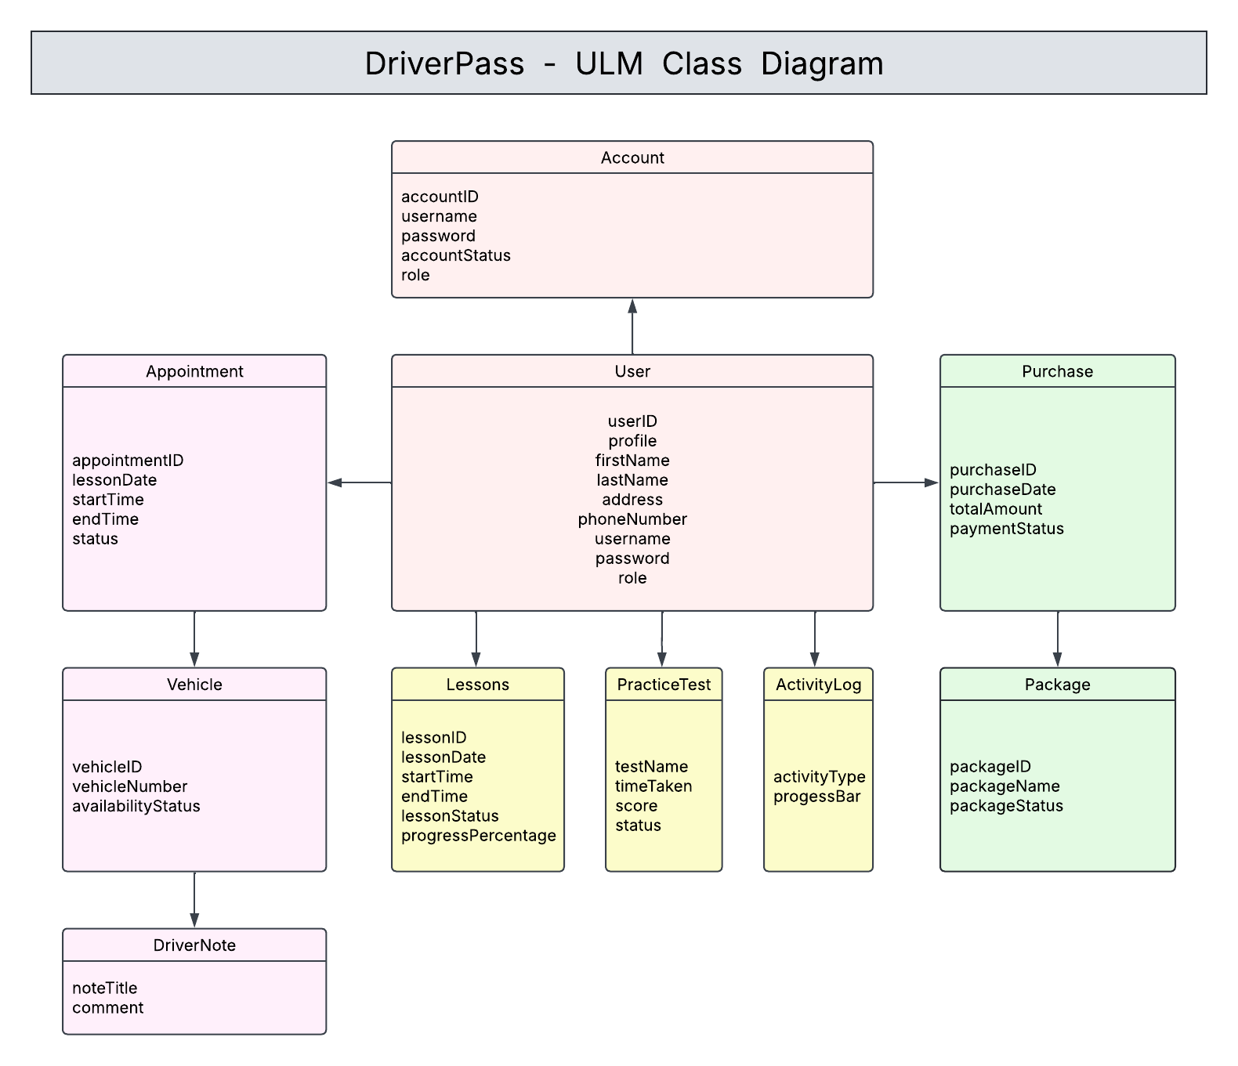

Technical Requirements
[Based on the diagrams you have created, describe the technical requirements of your system. These requirements should address the required hardware, software, tools, and infrastructure necessary for your system design.]

On the technical requirements, the Driver Pass will be a cloud-based web application system that can be accessed through a web browser, which can be used by many devices such as computers, laptops, tablets, and smart mobiles. The system should run fast in loading pages, processing, responding to user requests and payments within a few seconds. The system will be updated often when new updates are available. The system will run during all times except during downtimes of patching, fixing bugs, testing or updating. The system will update on packages, practice tests, courses and even the web layout once in a while to stay updated.

The hardware requirements include cloud hosting services and devices capable of running a web browser. The software requirements include a database management system, web application software, user authentication tools, and support for modern browsers to ensure users can access the system across different platforms.

On the tools needed for the system, we need to use database management tools to store customer information and driver pass information, version control to restore previous version of code and updates, and testing tools. In conclusion, the infrastructure is a cloud-based web browser that can be available on many devices through a secure internet connection, along with a centralized database to support data storage.

